Hydraulic Motor circuit diagram:

The IC on the right is an optocoupler which is used to trigger the P-channel mosfet which allows the relay and the solenoid to turn on at the same time.

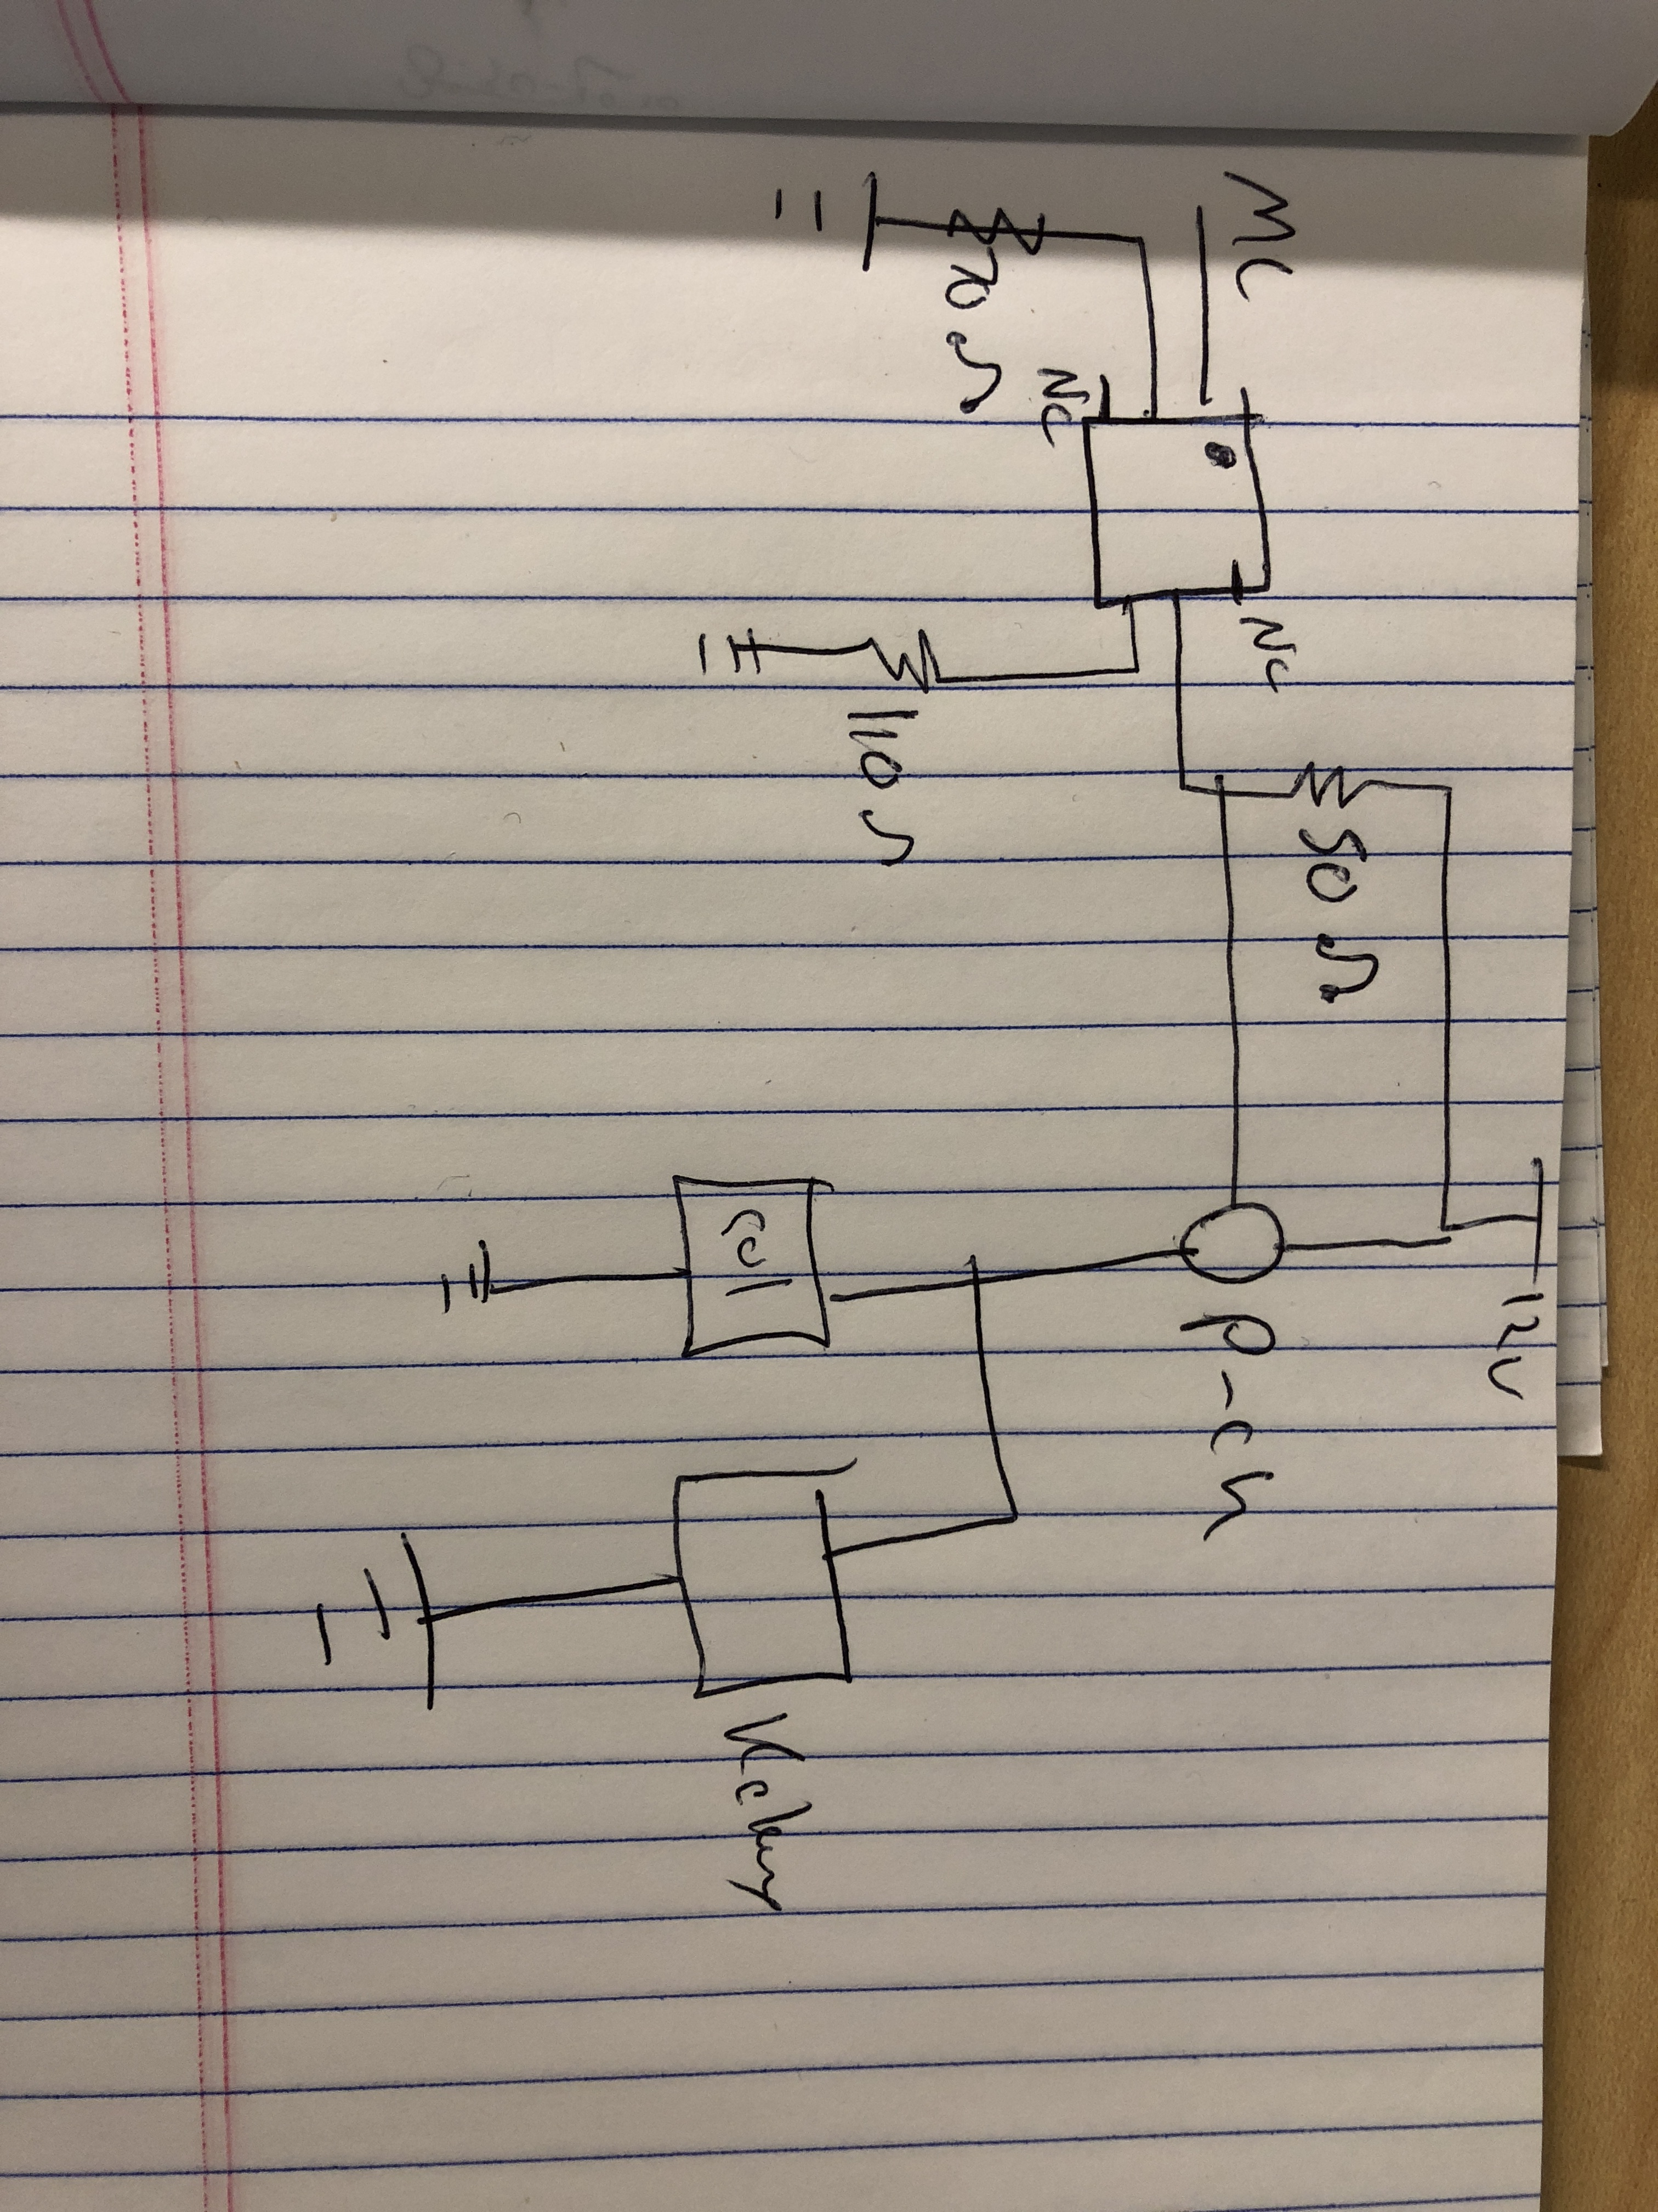

The solenoids are controlled by a low side driver made by Infineon. They take the 3.3v signal from the MCU through a current limiting resistor and act as a switch between the inductive load of the solenoid.